**Unit test coverage:**

Spring layer 75,7%

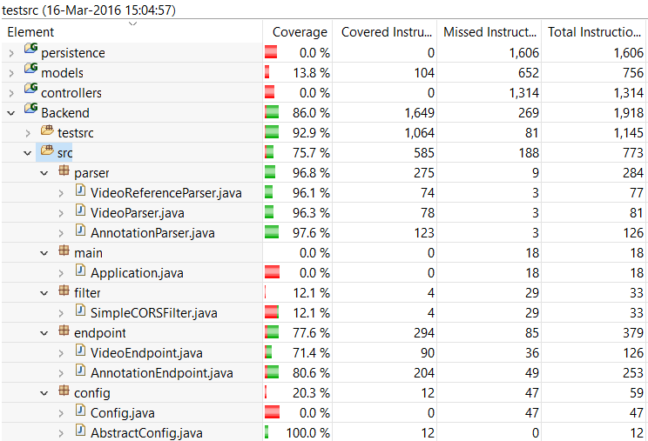

Controllers: 63.9%

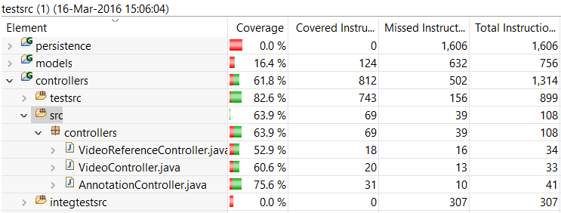

Models 76.9%

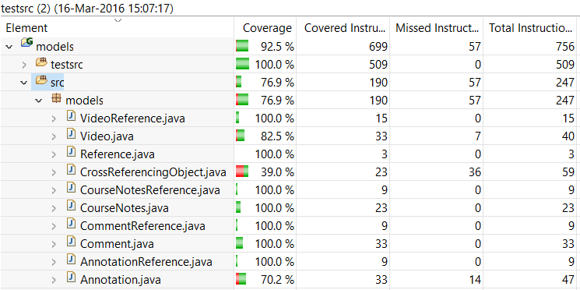

Persistence 53.4%

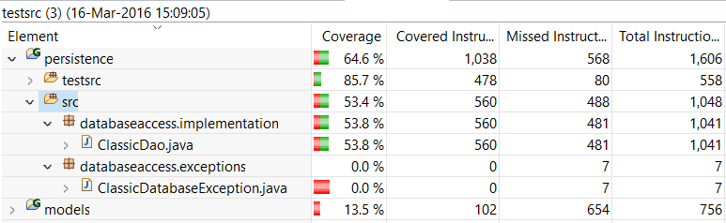

**Integration test coverage:**

Controllers-persistence

Controllers: 41.7%

Models: 38.1%

Persistence: 39.3%

